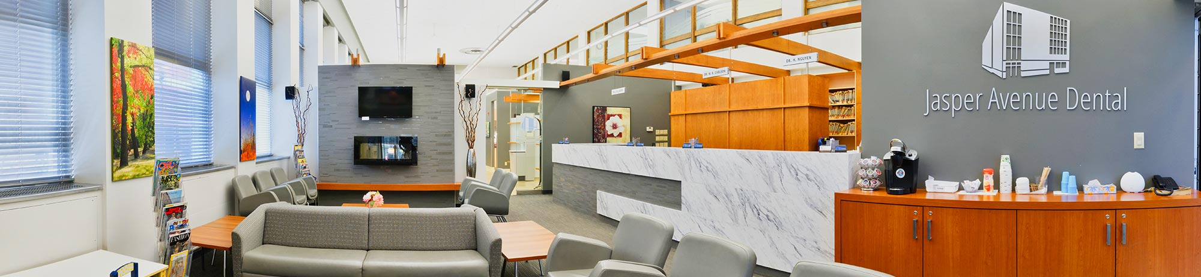
Jasper Avenue Dental
Suite 201, 10503 Jasper Avenue, Edmonton, AB, T5J 1Z4
(780) 780-423-1930 www.2th.com
Medical History Update
Patient Name: _____________________________________________________________
Please update the following information:
Address: ____________________________________________________
City: _______________________________ Province: __________ Postal Code: _____________

PHONE: Home: _______________ Work: _______________ Cell: _______________

Email: ________________________________________________

Emergency Contact Name: ___________________________________ Phone #: __________________________
Relationship: ______________________________________________

The following information is required to enable us to provide you with the best possible dental care. All information is strictly private, and is protected by doctor-patient confidentiality. Please fill in the entire form.

1. Are you being treated for any medical condition at the present or have you been treated in the past year?
Yes No Not Sure / Maybe
If yes, please explain: ___________________________________________________________________________________

2. Who is your primary care physician? _____________________________________________________________________

3. When has your last medical check-up? ___________________________________________________________________

4. Has there been any change to your general health in the past year?
Yes No Not Sure / Maybe
If yes, please explain: ___________________________________________________________________________________

5. Are you taking any prescriptions or over the counter medications, including herbal supplements?
Yes No Not Sure / Maybe
If yes, please explain: ___________________________________________________________________________________

Page 1
Jasper Avenue Dental
Suite 201, 10503 Jasper Avenue, Edmonton, AB, T5J 1Z4
(780) 780-423-1930 www.2th.com

6. Do you have or have you ever been treated for depression, anxiety or any psychiatric condition?
Yes No Not Sure / Maybe
If yes, please explain: ___________________________________________________________________________________

7. Do you have allergies?
Yes No Not Sure / Maybe
If you answered yes, please list using the following categories:
Medications Dental anesthetic
Latex / rubber products Other e.g. hay fever, foods, metals

8. Do you have or have you ever had asthma?
Yes No Not Sure / Maybe
If yes, please explain: ___________________________________________________________________________________

9. Do you have or have you ever had any heart or blood pressure problems?
Yes No Not Sure / Maybe
If yes, please explain: ___________________________________________________________________________________

10. Do you have or have you ever had a heart murmur, mitral valve prolapse or rheumatic fever?
Yes No Not Sure / Maybe
If yes, please explain: ___________________________________________________________________________________

11. Do you have a prosthetic or artificial joint?
Yes No Not Sure / Maybe
If yes, please explain: ___________________________________________________________________________________

12. Have you ever been advised by your doctor to take antibiotics before dental treatment?
Yes No Not Sure / Maybe
If yes, please explain: ___________________________________________________________________________________

13. Do you have any conditions or therapies that could affect your immune system?
Yes No Not Sure / Maybe
If yes, please explain: ___________________________________________________________________________________

Page 2

Jasper Avenue Dental
Suite 201, 10503 Jasper Avenue, Edmonton, AB, T5J 1Z4
(780) 780-423-1930 www.2th.com

14. Have you ever had hepatitis, jaundice or liver disease?
Yes No Not Sure / Maybe
If yes, please explain: ___________________________________________________________________________________

15. Do you bruise easily? Do you have a blood or bleeding disorder or problem?
Yes No Not Sure / Maybe
If yes, please explain: ___________________________________________________________________________________

16. Have you ever been hospitalized for any illness or operations?
Yes No Not Sure / Maybe
If yes, please explain: ___________________________________________________________________________________

17. Do you or have you ever had any of the following? Please check.
Chest pain, angina Shortness of breath Prosthetic heart valve

Seizures (epilepsy) Diet Pill therapy Drug / alcohol dependency

Heart attack Stroke Pacemaker

Arthritis Sinus problems Lung Disease

Tuberculosis Cancer Kidney Disease

Dementia Steroid therapy Diabetes

Stomach ulcer Thyroid disease Alzheimer’s

Are there any conditions or diseases not listed above that you have or have had?
Yes No Not Sure / Maybe
If yes, please explain: ___________________________________________________________________________________

18. Are there any diseases or medical problems that run in your family? E.G. diabetes, cancer, heart disease.
Yes No Not Sure / Maybe
If yes, please explain: ___________________________________________________________________________________

19. Do you smoke or chew tobacco products?
Yes No Not Sure / Maybe
If yes, how much per day: _______________________________________________________________________________
Page 3
Jasper Avenue Dental
Suite 201, 10503 Jasper Avenue, Edmonton, AB, T5J 1Z4
(780) 780-423-1930 www.2th.com

20. Are you nervous during dental treatment?
Yes No Not Sure / Maybe
If yes, please explain: ________________________________________________________________________

21. Do you have a tendency to faint?
Yes No Not Sure / Maybe
If yes, how many times in the last year?__________________________________________________________

22. Are you in recovery from drug or alcohol dependencies?
Yes No Not Sure / Maybe
If so, what is your anniversary date?_____________________________________________________________

23. For Women Only: Are you breastfeeding or pregnant?
Yes No Not Sure / Maybe
If pregnant, what is the expected delivery date? ____________________________________________________

To the best of my knowledge, the above information is correct:

Patient / Parent / Guardian Name: ______________________________________________________________

Patient / Parent / Guardian Signature: ___________________________________________________________

Response Date: __________________________________________

Page 4

